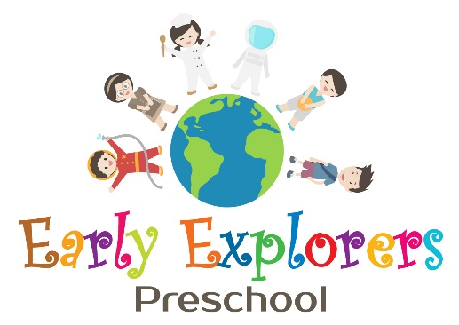
Early Explorers Preschool Family Style Dining Policy

Family Style Dining is a meal service approach that early care and education programs implement to address childhood obesity prevention and support children in developmentally appropriate mealtime experiences. All foods that meet the meal pattern requirements are placed on the table where children and adults sit together to share the meal. Children are encouraged to serve themselves independently or with adults’ help.

Early Explorers Preschool provides family style meals and snacks.

WHEN WE SERVE MEALS AND SNACKS FAMILY STYLE, ADUTLS AT THE PROGRAM:

- Serve as a role model eating and enjoying healthy foods
- Sit with children enjoying a relaxed and pleasant eating experience
- Engage children in interesting, language-building conversations
- Create play and learning experiences that support skills used in Family Style Dining

CHILDREN ENGAGED IN FAMILY STYLE MEAL SERVICE HAVE MORE OPPORTUNITIES TO:

- Try healthy foods
- Learn portion sizes
- Control how much they eat
- Engage in relaxed, pleasant mealtimes
- Develop positive food attitudes
- Build self-confidence, self-help and social skills

FAMILY ENGAGEMENT:
We value and understand the importance of engaging families within our program. We welcome families to participate in a family style meal with their child, and we will discuss with families the mealtimes that work best to meet the needs of families and the program.

